**Lab 1 – Report**

**Meet Kansara – 220929270 Roll no. 54**

**Aim: To familiarize with fundamental Python programming concepts**

**Code Execution and analysis:**

1. Input Handling:

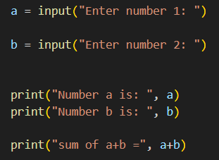

1. Strings:

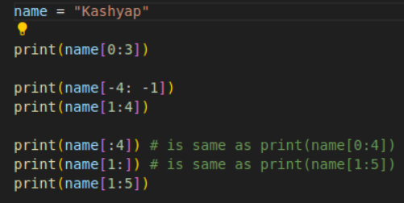

1. Lists:

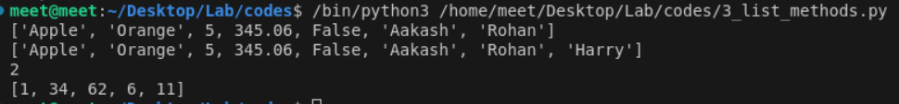

1. Tuples:

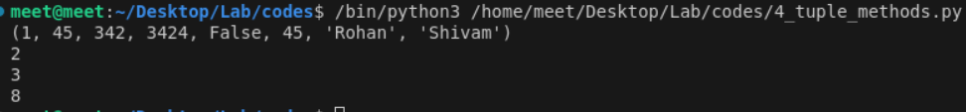

1. Dictionary:



1. Sets:



1. Conditional statements:

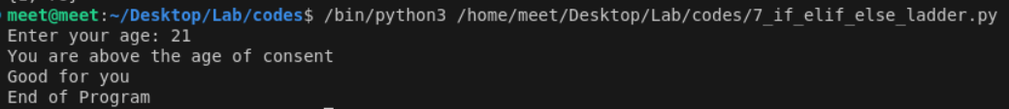

1. Break and continue statements:

1. Function definitions:



1. Classes and objects:



**Conclusion: A comprehensive introduction to essential Python programming concepts crucial for ROS applications was successfully achieved.**